**Ohm’s Law**

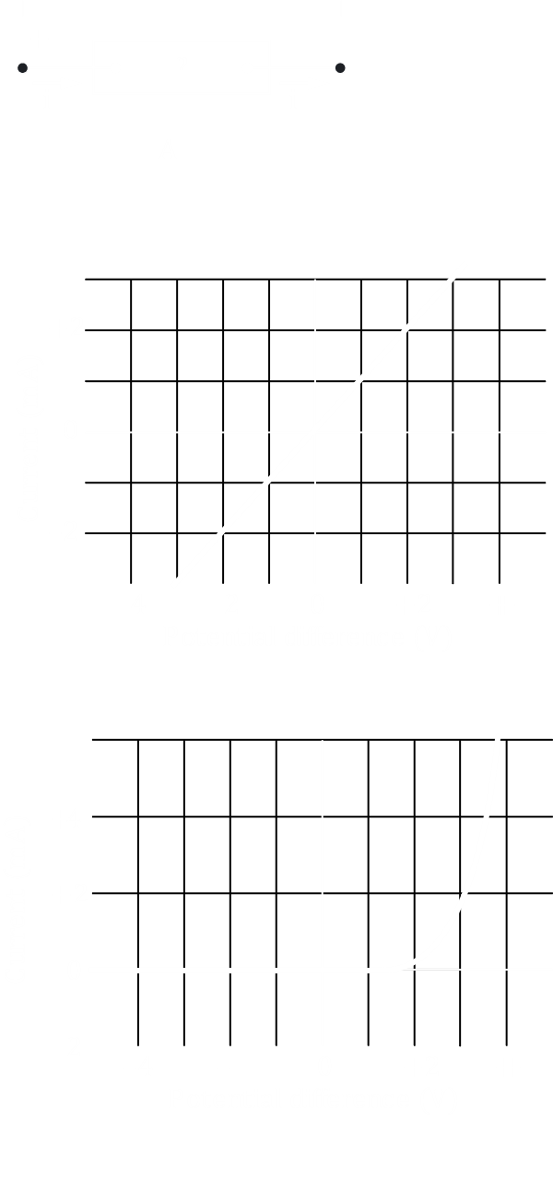

In $A$, $q=neAl$

$i=\frac{dq}{dt}=\int_{0}^{t}{dq}\int_{0}^{t}{idt}$

$∴q=it$

Current density (vector) $=$ current (scalar) $÷$ area (vector)

$$i=∫\vec{j}⋅\vec{A}$$

$$V=iR$$

$$\vec{E}=\vec{j}ρ$$

$$q=neAl$$

$$l=v_{d}t$$

$$t=l/v_{d}$$

$$t=l/v_{d}$$

$$i=\frac{q}{t}=\frac{neAl}{\frac{l}{v_{d}}}=neAv_{d}$$

$$i=neAv_{d}$$

$$\frac{i}{A}=j$$

$$v_{d}=\frac{j}{ne}$$



Energy $=BH$

Ohmic Conductor – Follows Ohm’s Law

$i=∫\vec{j}⋅\vec{ds}$ $j$– current density

$ds$– normal (direction of electron motion)



$v_{s}≅c$ $v_{s}$– drift speed

$v_{d}$– drift velocity

$v_{s}≫v_{d}$



$$∫ds=A$$

$$F=e\vec{E}$$

$$α=\frac{e\vec{E}}{m_{e}}$$

$$i=∫\vec{j}⋅\vec{ds}$$

$$V=-∫E⋅dr$$

$$v_{d}=ατ$$

$$\frac{j}{ne}=\frac{e\vec{E}}{m_{e}}$$

$V=iR$ (macroscopic Ohm’s law)

$e=R=\frac{-∫E⋅dr}{∫\vec{j}⋅\vec{ds}}$ (microscopic Ohm’s law)

$\frac{\frac{E}{ρ}}{ne}=\frac{eE}{m}τ$ resistivity independent of $E$

The macroscopic form of Ohm's law is $V=IR$.

This is not the real Ohm's law. It is only used so that we can measure the value of $V$, $I$ and $R$.

The real Ohm's law is:

$$\vec{E}=\vec{J}ρ$$

where $E$ is the electric potential and

$ρ$ is the resistivity of the conductor.

This cannot be measured.

$$\vec{J}=\frac{I}{A}$$

where $I$ is the current and

$A$ is the cross-sectional area of the conductor.

$$I=\int{\vec{J}⋅\vec{δs}}$$

Here, $I$ can only be scalar,

$\vec{J}$ can only be vector and

$\vec{δs}$ can only be vector

The speed of an electron is almost equal to the speed of light.

$$m_{n}>m_{p}≫m_{e}$$